APNIC

🌐 What Is APNIC?
# Source: Chatgpt (GPT‑5 Mini) at [12/15/2025]
APNIC stands for Asia-Pacific Network Information Centre. It is one of the five Regional Internet Registries (RIRs) responsible for distributing and managing:
- IPv4 and IPv6 address blocks
- Autonomous System Numbers (ASNs)
…for organizations in the Asia-Pacific region.

🧠 Simple Definition:
# Source: Chatgpt (GPT‑5 Mini) at [12/15/2025]
APNIC is the official organization that allocates IP addresses and AS numbers to internet service providers, data centers, and enterprises in the Asia-Pacific region.

🌍 Region Covered by APNIC
# Source: Chatgpt (GPT‑5 Mini) at [12/15/2025]
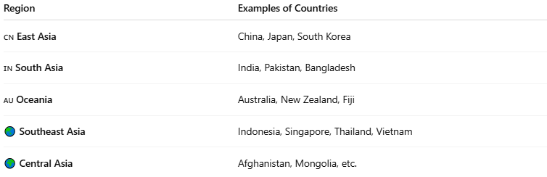
Region | Examples of Countries
🇨🇳 East Asia | China, Japan, South Korea
🇮🇳 South Asia | India, Pakistan, Bangladesh
🇦🇺 Oceania | Australia, New Zealand, Fiji
🌏 Southeast Asia | Indonesia, Singapore, Thailand, Vietnam
🌍 Central Asia | Afghanistan, Mongolia, etc.

🔧 Key Functions of APNIC
# Source: Chatgpt (GPT‑5 Mini) at [12/15/2025]
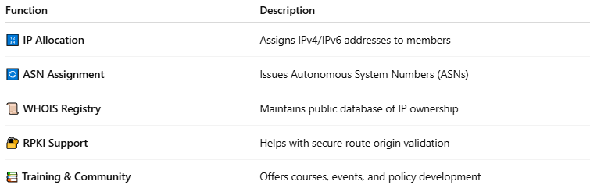

Function | Description
🔢 IP Allocation | Assigns IPv4/IPv6 addresses to members
🔄 ASN Assignment | Issues Autonomous System Numbers (ASNs)
📜 WHOIS Registry | Maintains public database of IP ownership
🔐 RPKI Support | Helps with secure route origin validation
📚 Training & Community | Offers courses, events, and policy development

🧩 Structure of APNIC
# Source: Chatgpt (GPT‑5 Mini) at [12/15/2025]
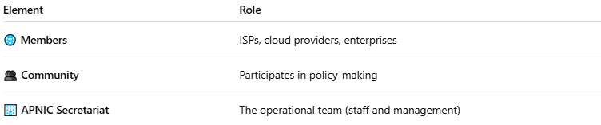

Element | Role
🌐 Members | ISPs, cloud providers, enterprises
👥 Community | Participates in policy-making
🏢 APNIC Secretariat | The operational team (staff and management)

🧾 Example WHOIS (from APNIC)
# Source: Chatgpt (GPT‑5 Mini) at [12/15/2025]
For IP: 1.1.1.1 (Cloudflare DNS):
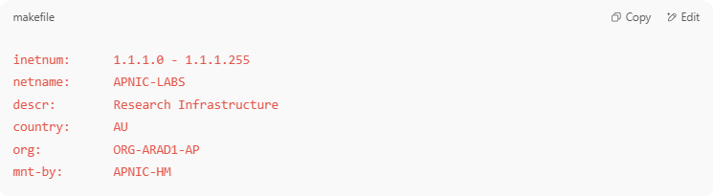
inetnum: 1.1.1.0 - 1.1.1.255
netname: APNIC-LABS
descr: Research Infrastructure
country: AU
org: ORG-ARAD1-AP
mnt-by: APNIC-HM

🌐 Website & Tools
# Source: Chatgpt (GPT‑5 Mini) at [12/15/2025]
- Official website: https://www.apnic.net
- WHOIS search: https://wq.apnic.net
- IP address reports, training, and technical support

✅ Summary
# Source: Chatgpt (GPT‑5 Mini) at [12/15/2025]
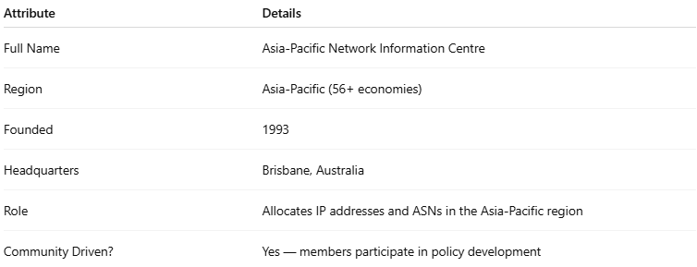

Attribute | Details
Full Name | Asia-Pacific Network Information Centre
Region | Asia-Pacific (56+ economies)
Founded | 1993
Headquarters | Brisbane, Australia
Role | Allocates IP addresses and ASNs in the Asia-Pacific region
Community Driven? | Yes — members participate in policy development

